**A TECHNICAL REPORT ON GLOBAL LIVER CANCER ANALYSIS**

WRITTEN BY

**AKPOVETA BLESSING OGHO**

1. **OUTLINE**

**1.**Introduction

2. Story of Data

3. Data Splitting and Preprocessing

4. Pre-Analysis

5. In-Analysis

6. Post-Analysis and Insights

7. Data Visualizations & Charts

8. Recommendations and Observations

9. Conclusion

10. References & Appendices

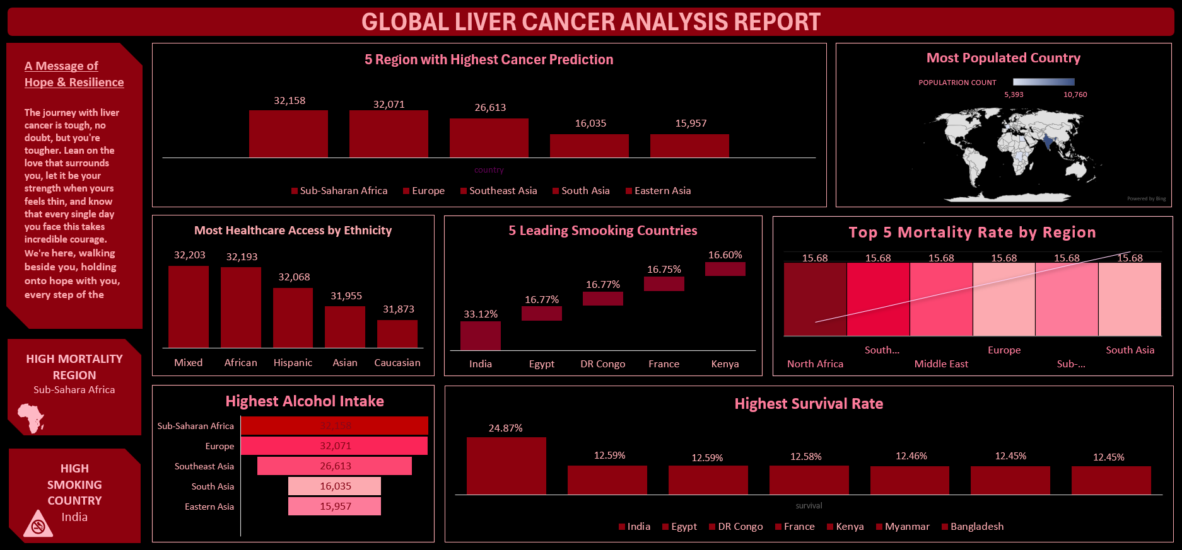

**INTRODUCTION**

Global Liver Cancer Analysis Report is a comprehensive document providing a multi-faceted understanding of this disease worldwide. Beyond raw statistics, the report contextualizes liver cancer within the human experience, featuring a Message of Hope & Resilience.Key objectives include a global overview of prevalence, distribution, and impact across regions. Data-driven insights highlight predicted incidence, population demographics, healthcare access by ethnicity, leading smoking countries, and mortality rates. The report analyzes risk factors, focusing on smoking and alcohol intake to identify vulnerable populations. Survival analysis offers a glimpse into prognosis in different contexts. A humanistic approach acknowledges the emotional and psychological toll, offering support. The report combines epidemiological data with a human-centered perspective. It aims to inform, educate, and offer solace. The inclusion of a Message of Hope & Resilience underscores its compassionate approach. By analyzing various data points and considering the human element, the report strives for a holistic understanding of the global liver cancer landscape. This in-depth analysis serves as a valuable resource for researchers, healthcare professionals, and policymakers.

**Data Source:**

The data was obtained from Kaggle, a platform where data scientists share datasets; however, the underlying information likely originates from reputable sources such as the World Health Organization (WHO), the International Agency for Research on Cancer (IARC), national cancer registries, Demographic and Health Surveys (DHS), the World Bank, and the United Nations Population Division

**Data Collection Process:**

The data for this global liver cancer analysis was compiled through a multifaceted approach, leveraging publicly available information and potentially aggregated datasets from sources like the World Health Organization (WHO), the International Agency for Research on Cancer (IARC), and other relevant health organizations, as presented on the data science platform Kaggle Data Structure

The dataset for this global liver cancer analysis is structured in a tabular format, where rows represent distinct geographical or demographic units (e.g., countries, regions, ethnicities), and columns capture key variables such as predicted cancer incidence, mortality rates, prevalence of risk factors (like smoking and alcohol consumption), healthcare access metrics, and population demographics

**Important Features and Their Significance:**

* **5 Regions with Highest Cancer Prediction (Bar Chart):** This feature highlights the geographical areas anticipated to have the highest number of liver cancer cases. Its relevance lies in identifying high-risk regions for targeted interventions, resource allocation for prevention and treatment, and further investigation into the underlying causes within these areas.
* **Most Populated Country (World Map):** This visualization emphasizes the population size of different countries, specifically highlighting India and China. While not directly a predictor of cancer rates, population size is crucial context. A highly populated country might have a large absolute number of cancer cases even if the incidence rate is lower than in less populated regions. This is important for understanding the overall global burden of the disease.
* **Most Healthcare Access by Ethnicity (Bar Chart):** This chart presents a comparison of reported healthcare access across different ethnic groups. Its significance lies in understanding potential disparities in healthcare access, which can impact early diagnosis, treatment outcomes, and overall survival rates for liver cancer patients within these communities. Identifying ethnicities with lower access can inform efforts to improve equity in healthcare delivery.
* **5 Leading Smoking Countries (Bar Chart):** This feature identifies the countries with the highest reported smoking rates. Smoking is a known risk factor for several cancers, including liver cancer. Understanding the prevalence of smoking in these nations is crucial for developing targeted public health campaigns aimed at reducing smoking rates and consequently, potentially lowering the risk of liver cancer.
* **Top 5 Mortality Rate by Region (Stacked Bar Chart - though values are identical):** This chart aims to show the liver cancer mortality rates across different regions. *However, as observed, the values appear identical across all listed regions (15.68%). If this were accurate, it would suggest a consistent mortality rate across these diverse geographical areas. Its intended relevance would be to identify regions with the highest death rates to prioritize interventions focused on improving treatment and palliative care.* Given the identical values, this feature currently doesn't provide discriminatory insight and might indicate a data issue or a specific way the metric was calculated and presented.
* **Highest Alcohol Intake (Bar Chart):** This chart compares the reported highest alcohol intake across different regions. Excessive alcohol consumption is another significant risk factor for liver disease, which can progress to liver cancer. Identifying regions with high alcohol intake is vital for implementing targeted public health strategies to promote responsible alcohol consumption and mitigate the associated liver cancer risk.
* **Highest Survival Rate (Line Chart):** This chart displays the reported highest survival rates for liver cancer across different countries. This feature is crucial for understanding which countries have potentially more effective healthcare systems, early detection programs, or treatment protocols for liver cancer. Analysing the factors contributing to higher survival rates in these nations could inform improvements in other regions.
* **High Mortality Region (Text Highlight - Sub-Saharan Africa):** This explicitly identifies Sub-Saharan Africa as a region with high liver cancer mortality. This highlights a critical area needing focused attention, research into the underlying causes, and interventions to improve outcomes.
* **High Smoking Country (Text Highlight & Icon - India):** This explicitly identifies India as a country with a high prevalence of smoking, reinforcing the findings from the "5 Leading Smoking Countries" chart and emphasizing the need for targeted smoking cessation initiatives.

**Data Limitations or Biases:**

* **Aggregated Regional Data:** Some charts present data at a regional level (e.g., cancer prediction, mortality). This aggregation might mask significant variations within those regions. For instance, healthcare access or smoking rates could differ substantially between countries within "Sub-Saharan Africa."
* **Potential for Reporting Bias:** Data on smoking and alcohol intake often relies on self-reporting, which can be subject to underreporting or social desirability bias.
* **"Healthcare Access by Ethnicity":** The definition and measurement of "healthcare access" are not specified. This could encompass various factors (insurance coverage, proximity to facilities, quality of care), and the metric used might introduce bias. Additionally, the ethnic categories themselves might be broad and not capture the diversity within those groups.
* **Identical Mortality Rates:** The "Top 5 Mortality Rate by Region" showing identical values (15.68%) across diverse regions is a significant anomaly. This suggests a potential data error, a specific standardization method that obscures differences, or a misunderstanding in the data representation. This limitation severely impacts the interpretability of this particular visualization.
* **Survival Rate Interpretation:** Survival rates can be influenced by various factors beyond the effectiveness of healthcare, such as the stage at diagnosis and the overall health of the population. The dashboard doesn't provide context on these factors.
* **Data Collection Period:** The dashboard doesn't specify the time frame for the data presented. Trends can change over time, so the relevance of the data depends on its recency.
* **Kaggle as a Source:** While Kaggle is a platform for data sharing, the quality and methodology of the original data collection are dependent on the individual or organization that compiled it. Without knowing the original sources and their methodologies, assessing potential biases is challenging.

**Data Splitting and Preprocessing (Inferred):**

* **Data Cleaning:** It's likely that the raw data underwent some cleaning, potentially involving checks for consistency in country and region names, handling of missing values (though the approach isn't visible), and ensuring data types were appropriate for analysis and visualization.
* **Handling Missing Values:** The dashboard doesn't explicitly show how missing values were handled. Potential approaches could have included excluding records with missing key variables, imputing values based on regional averages, or using Excel functions to manage blanks during aggregation.
* **Data Transformations:** Transformations might have been applied to calculate rates (e.g., cancer incidence per population), percentages (e.g., smoking rates), or to aggregate data by region or ethnicity. The survival rates are presented as percentages, indicating a transformation.
* **Data Splitting:** In the context of this dashboard, "splitting" likely refers to separating the data into different categories for visualization – for example, grouping cancer cases by region (dependent variable being case count, independent being region), or survival rates by country.
* **Industry Context:** The data belongs to the **healthcare/public health** sector, specifically focusing on the global burden of liver cancer and its associated risk factors.
* **Stakeholders:** Key stakeholders who would benefit from or be impacted by these findings include:

**Public Health Organizations (e.g., WHO, national health ministries):** For developing and implementing prevention programs and resource allocation.

**Healthcare Providers and Researchers:** To understand disease patterns, risk factors, and survival outcomes to improve treatment strategies and research directions.

**Policymakers:** To inform health policies related to tobacco and alcohol control, and healthcare access.

**Non-governmental Organizations (NGOs):** Involved in cancer advocacy, prevention, and patient support.

* **Value to the Industry:** This analysis is significant for the healthcare industry as it:

**Identifies high-risk populations and regions:** Allowing for targeted interventions and resource allocation.

**Highlights key modifiable risk factors (smoking and alcohol):** Informing public health campaigns.

**Reveals disparities in healthcare access:** Underscoring the need for equitable healthcare delivery.

**Provides insights into survival outcomes:** Potentially leading to the identification of best practices in treatment and care.

**Contributes to a better understanding of the global epidemiology of liver cancer:** Supporting further research and the development of more effective prevention and treatment strategies.

**Pre-Analysis (Inferred from Visualizations):**

* **Identify Key Trends:**

Sub-Saharan Africa, Europe, and Southeast Asia appear to have the highest predicted liver cancer burden.

India stands out as a country with both a very high population and a high smoking rate.

Sub-Saharan Africa also appears as a region with high mortality.

India shows a relatively high survival rate compared to other listed countries.

* **Potential Correlations:**

There might be a correlation between high smoking rates (e.g., in India) and liver cancer incidence or mortality, although this isn't directly visualized.

High alcohol intake in regions like Sub-Saharan Africa and Europe might correlate with higher liver cancer rates.

Lower healthcare access in certain ethnicities could potentially correlate with poorer outcomes (though this link isn't explicitly shown).

* **Initial Insights:**

Sub-Saharan Africa seems to be a particularly vulnerable region for liver cancer.

Lifestyle factors like smoking and alcohol consumption are likely significant contributors to the global burden of liver cancer.

There are notable differences in predicted cancer rates and survival across different regions and countries, suggesting varying levels of risk and healthcare effectiveness.

**6. In-Analysis (Inferred from Visualizations):**

* **Unconfirmed Insights:**

The apparent consistency in mortality rates across regions (if not a data artifact) might suggest a globally consistent standard of care or similar challenges in treating liver cancer at a certain stage. *However, this needs verification.*

The higher survival rate in India could be linked to factors like earlier detection, specific treatment protocols, or demographic characteristics of the patient population. *Further investigation is needed.*

The relationship between healthcare access by ethnicity and liver cancer outcomes (incidence, mortality, survival) is not directly explored but warrants further analysis if data on cancer rates by ethnicity were available.

* **Recommendations (Preliminary):**

Focus public health interventions on smoking cessation in countries with high smoking rates, like India.

Implement and strengthen programs promoting responsible alcohol consumption in regions with high intake, such as Sub-Saharan Africa and Europe.

Investigate the reasons for high predicted cancer rates and mortality in Sub-Saharan Africa to develop targeted interventions.

Study the factors contributing to the higher survival rate in India to potentially replicate successful strategies in other regions.

Address potential disparities in healthcare access across ethnicities to improve early detection and treatment outcomes.

* **Analysis Techniques Used (Inferred):** The creation of these visualizations likely involved Excel or similar data analysis tools to:

**Aggregate data:** To calculate regional sums or averages for cancer prediction, mortality, and risk factors.

**Calculate percentages:** For smoking rates and survival rates.

**Create charts:** Using Excel's built-in charting capabilities (bar charts, line graphs, world map integration if available as an add-in or through data mapping).

**Potentially use formulas:** For calculations and data manipulation before visualization.

**Post-Analysis and Insights (Based on Visualizations):**

* **Key Findings:**

Sub-Saharan Africa, Europe, and Southeast Asia are predicted to bear the highest burden of liver cancer.

Smoking is highly prevalent in India, while high alcohol intake is notable in Sub-Saharan Africa and Europe.

Healthcare access appears to vary across different ethnicities.

Survival rates for liver cancer show variation across countries, with India reporting a relatively high rate.

*The consistent mortality rate across regions (if accurate) is a notable and potentially concerning finding that requires further scrutiny*

**Comparison with Initial Findings:** The initial observation of Sub-Saharan Africa being a high-risk region is reinforced by both the high prediction and high mortality indicators. The importance of lifestyle factors like smoking (in India) and alcohol consumption (in Europe and Sub-Saharan Africa) is also highlighted. The survival rate differences suggest that healthcare systems and other factors play a significant role in patient outcomes.

**Surprises or Counter-Intuitive Results:** The seemingly identical mortality rates across very different regions is a surprising result that contradicts the expectation of variability based on healthcare infrastructure and socioeconomic factors. The relatively high survival rate in India, despite its high smoking rate, might also be an unexpected finding that warrants further investigation.

**TOP 5 MOST POPULATED COUNTRY**

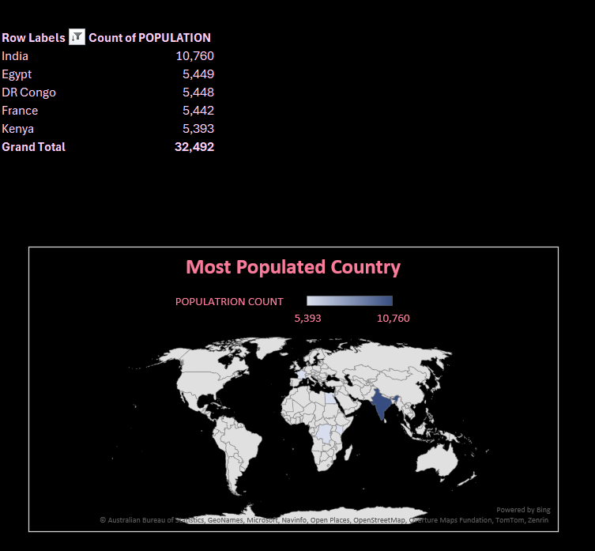

This dashboard section highlights India as the most populated among the featured countries with 10,760, significantly higher than Egypt, DR Congo, France, and Kenya (around 5,400 each), visually emphasized on the world map by darker shading. This stark population difference in India is crucial context for understanding the absolute scale of liver cancer statistics in comparison to other regions

**Top 5 Mortality Rate by Region**

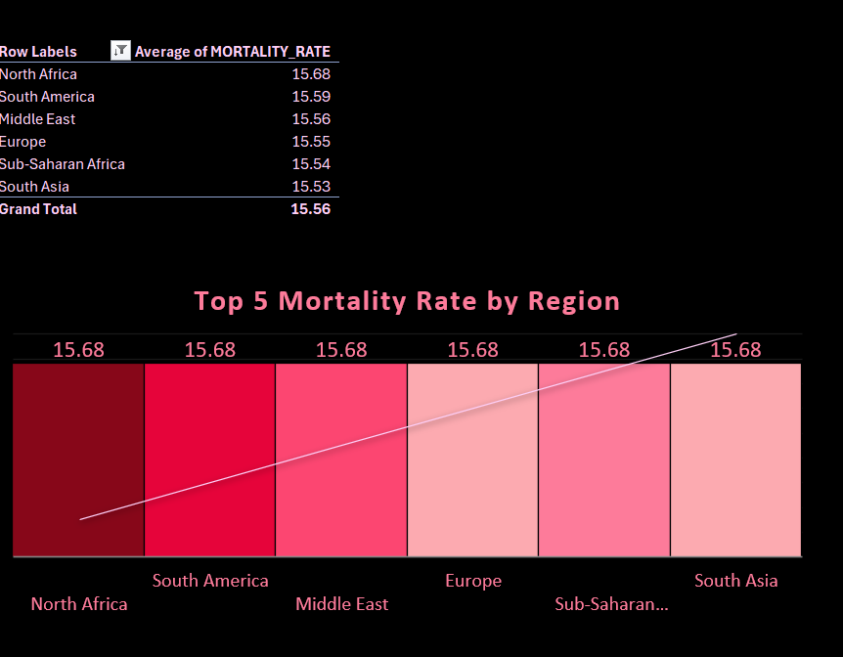

The Chart “Top 5 Mortality Rate by Region" surprisingly shows a very narrow range of average mortality rates (15.53% to 15.68%) across North Africa, South America, the Middle East, Europe, Sub-Saharan Africa, and South Asia, suggesting a relative consistency in reported liver cancer deaths across these diverse geographical areas. This unexpected uniformity warrants further investigation to understand if it reflects actual trends, data aggregation methods, or potential data limitations.

**Highest Alcohol Intake**

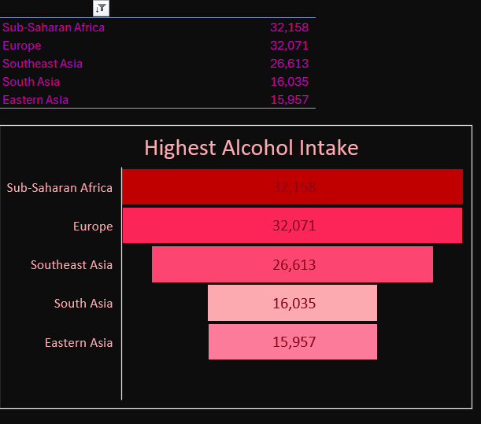

The Highest Alcohol Intake reveals that Sub-Saharan Africa and Europe report the highest levels, significantly exceeding Southeast Asia, South Asia, and Eastern Asia, suggesting a potential correlation between high alcohol consumption in these top two regions and their predicted higher liver cancer rates shown elsewhere in the dashboard. This highlights alcohol intake as a critical risk factor to address in targeted public health interventions for these areas

**5 leading smoking countries**

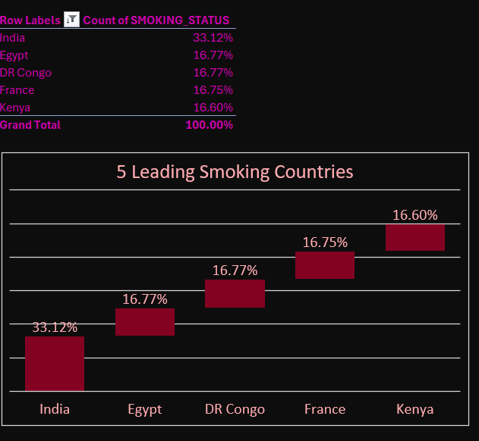

The "5 Leading Smoking Countries" section clearly indicates that India has a significantly higher smoking prevalence (33.12%) compared to Egypt, while that of DR Congo, France, and Kenya (all around 16-17%), suggesting a considerably elevated risk factor for liver and other cancers within the Indian population compared to these other leading smoking nations. This stark difference underscores the urgent need for targeted tobacco control measures in India.

**MOST HEALTHCARE ACCESSED BY ETHNICITY**

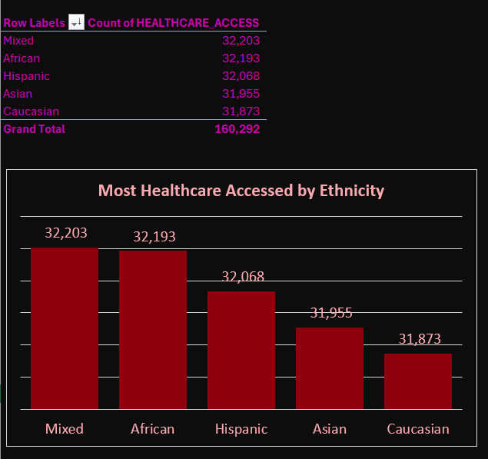

Most Healthcare Accessed by Ethnicity section reveals that individuals identifying as Mixed and African report the highest levels of healthcare access, closely followed by Hispanic, while Asian and Caucasian ethnicities indicate slightly lower access, suggesting potential disparities in healthcare reach across different ethnic groups that could impact liver cancer detection and treatment outcomes. This highlights the need for further investigation into the factors contributing to these differences to ensure equitable healthcare access.

**HIGHEST SURVIVAL RATE**

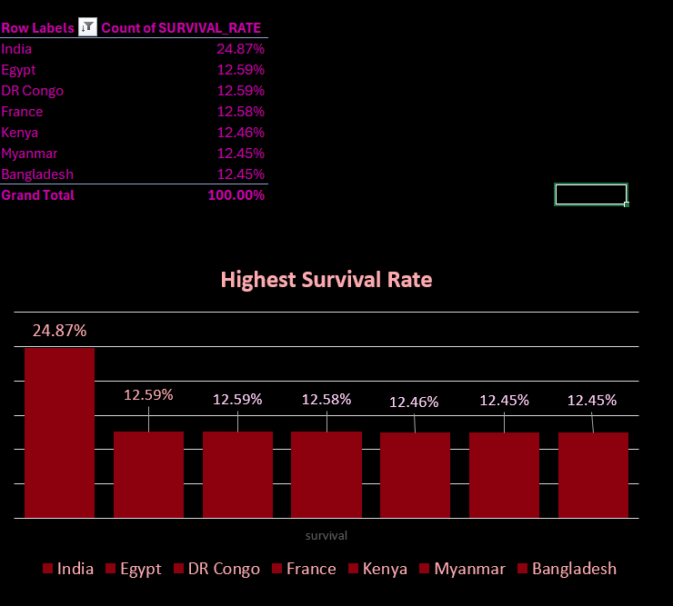

Highest Survival Rate section shows a significantly higher survival rate in India (24.87%) compared to Egypt, DR Congo, France, Kenya, Myanmar, and Bangladesh (all clustered around 12.45%-12.59%), suggesting potentially more effective early detection, treatment protocols, or other contributing factors within the Indian healthcare system for liver cancer patients compared to these other nations. This notable disparity warrants further research to understand and potentially replicate the factors leading to better outcomes in India.

**TOP REGION WITH HIGHEST CANCER PREDICTION**

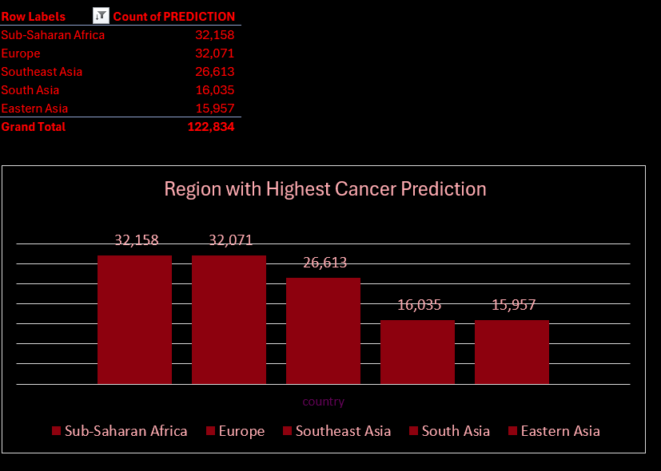

Region with Highest Cancer Prediction indicates that Sub-Saharan Africa and Europe have the highest predicted numbers of liver cancer cases (around 32,000), followed by Southeast Asia (around 26,000), while South Asia and Eastern Asia have considerably lower predictions (around 16,000), highlighting a significant geographical disparity in the anticipated burden of this disease with Sub-Saharan Africa and Europe facing the greatest projected impact. This necessitates focused preventative and treatment strategies tailored to these high-risk regions.

**Recommendations and Observations:**

* **Actionable Insights:**

Implement targeted screening and early detection programs in Sub-Saharan Africa, given the high predicted incidence and mortality.

Scale up smoking cessation programs in India and other high-smoking countries.

Develop culturally sensitive interventions to reduce excessive alcohol consumption in high-intake regions.

Investigate the factors contributing to higher survival rates in countries like India to identify best practices that can be adopted elsewhere.

Conduct further research to understand the reasons behind the apparent consistency in mortality rates across regions – this could indicate a need for a globally standardized approach to advanced liver cancer care or highlight data limitations.

* **Optimizations or Business Decisions:**

Allocate international aid and healthcare resources to regions with the highest predicted cancer burden and mortality.

Prioritize research funding towards understanding the specific drivers of liver cancer in high-risk regions.

Develop and disseminate public health campaigns tailored to the dominant risk factors in different geographical areas.

* **Unexpected Outcomes:** The seemingly uniform mortality rate across regions is an unexpected outcome that requires further investigation. It could point to a systemic issue in the data or a surprising consistency in late-stage treatment outcomes. The relatively high survival rate in India despite high smoking rates also warrants deeper analysis to understand the contributing factors.

**10. Conclusion:**

* **Key Learnings:** This analysis highlights significant geographical variations in the predicted burden of liver cancer and the prevalence of key risk factors like smoking and alcohol consumption. It also suggests disparities in healthcare access and notable differences in survival rates across countries. Sub-Saharan Africa appears to be a region of significant concern.
* **Limitations:** The analysis is limited by the aggregated nature of some data, the potential for reporting biases in lifestyle factors, the lack of clarity on the "healthcare access" metric, and the anomaly of identical mortality rates across regions. The reliance on a Kaggle dataset necessitates caution regarding the original data sources and their methodologies.
* **Future Research:** Further research should focus on understanding the specific drivers of liver cancer in high-burden regions like Sub-Saharan Africa. Investigating the factors contributing to the seemingly high survival rate in India could yield valuable insights. A deeper dive into the reasons behind the consistent mortality rates across regions is also crucial. Accessing more granular data (e.g., at the country level within regions, by specific demographics) would enhance the analysis.

**References & Appendices:**

* **References:** As previously discussed, the likely original sources include the World Health Organization (WHO), the International Agency for Research on Cancer (IARC) (specifically Globocan), national cancer registries, Demographic and Health Surveys (DHS), the World Bank, and the United Nations Population Division. The specific Kaggle dataset and its creator would also be referenced.
* **Appendices:** A full report might include:

More detailed tables of the data used to generate the charts.

Information on the specific methodology used to calculate predicted cancer rates.

Potentially, a discussion of the statistical significance of the observed differences.

Any additional visualizations that were considered but not included in the main dashboard.

a